**Cornell Caustic**

**University of Minho**

**Master in Informatics Engineering**

Computer Graphics

Display and Lighting II

June 2016

Bruno Miguel da Silva Barbosa 67646

Carlos Rafael Cruz Antunes 67711

Tomás Moreira Ferreira 67701

**Table of Contents**

Abstract 4

Introduction 4

Experiments 5

Hypotheses 5

Results 6

Path Tracing 7

Adaptive 8

Best Candidate 9

Halton 10

Low Discrepancy 11

Random 12

Stratified 13

Photon Map With No Caustic Photons 14

Adaptive 15

Best Candidate 16

Halton 17

Low Discrepancy 18

Random 19

Stratified 20

Photon Map With Caustic Photons 21

Best Candidate 22

Halton 23

Low Discrepancy 24

Random 25

Stratified 26

Reference Image 27

Conclusion 28

**Table of Figures**

Figure 1. Default scene, rendered with path tracing. 4

Figure 2. How a caustic shadow is formed. 6

Figure 3. Scene rendered with path tracing and an adaptive sampler. 8

Figure 4. Scene rendered with path tracing and a best candidate sampler. 9

Figure 5. Scene rendered with path tracing and a halton sampler. 10

Figure 6. Scene rendered with path tracing and a low discrepancy sampler. 11

Figure 7. Scene rendered with path tracing and a random sampler. 12

Figure 8. Scene rendered with path tracing and a stratified sampler. 13

Figure 9. Scene rendered with photon mapping and an adaptive sampler. 15

Figure 10. Scene rendered with photon mapping and a best candidate sampler. 16

Figure 11. Scene rendered with photon mapping and a halton sampler. 17

Figure 12. Scene rendered with photon mapping and a low discrepancy sampler. 18

Figure 13. Scene rendered with photon mapping and a random sampler. 19

Figure 14. Scene rendered with photon mapping and a stratified sampler. 20

Figure 15. Scene rendered with photon mapping (with caustic photons) and a best candidate sampler. 22

Figure 16. Scene rendered with photon mapping (with caustic photons) and a halton sampler. 23

Figure 17. Scene rendered with photon mapping (with caustic photons) and a low discrepancy sampler. 24

Figure 18. Scene rendered with photon mapping (with caustic photons) and a random sampler. 25

Figure 19. Scene rendered with photon mapping (with caustic photons) and a stratified sampler. 26

Figure 20. Reference scene. 27

# Abstract

This report explains the entire process of a brief analysis under the subject of Computer Graphics, more specifically about Photorealistic Image Rendering through the Ray Tracing technique. The project was carefully structured in order to easily understand its real purpose. First of all, we start by identifying the actual problem which is, in a few words, the simulation of caustic shadows. Caustics are defined as a group of light rays that are reflected or refracted by curved transparent objects. The next step was planning the experimentation and predict some of the possible results according to each possible approach. Then, it was time to proceed to the rendering experimentation where beyond the final image, it is also taken into account the elapsed time. At last, comes the study of the obtained results and the choice of the best relation between image quality and time spent on it.

# Introduction

This project intends to evaluate different global illumination algorithms’ performance and quality. To do this, the group was given a scene to work with (represented on Figure 1). This image’s resolution is 1024 by 1024 and was rendered using PBRT version 2 (using the surface integrator “path”). The PBRT will also be used to fulfil the purpose of this project by rendering the various experiments. The scene to be studied has various typical surfaces seen on global illumination demos, such as a glossy teapot and ceiling, a mirror, and a crystal-like “killeroo” model. Our particular focus will be on the “killeroo” model, by trying to get the best caustic shadow possible.

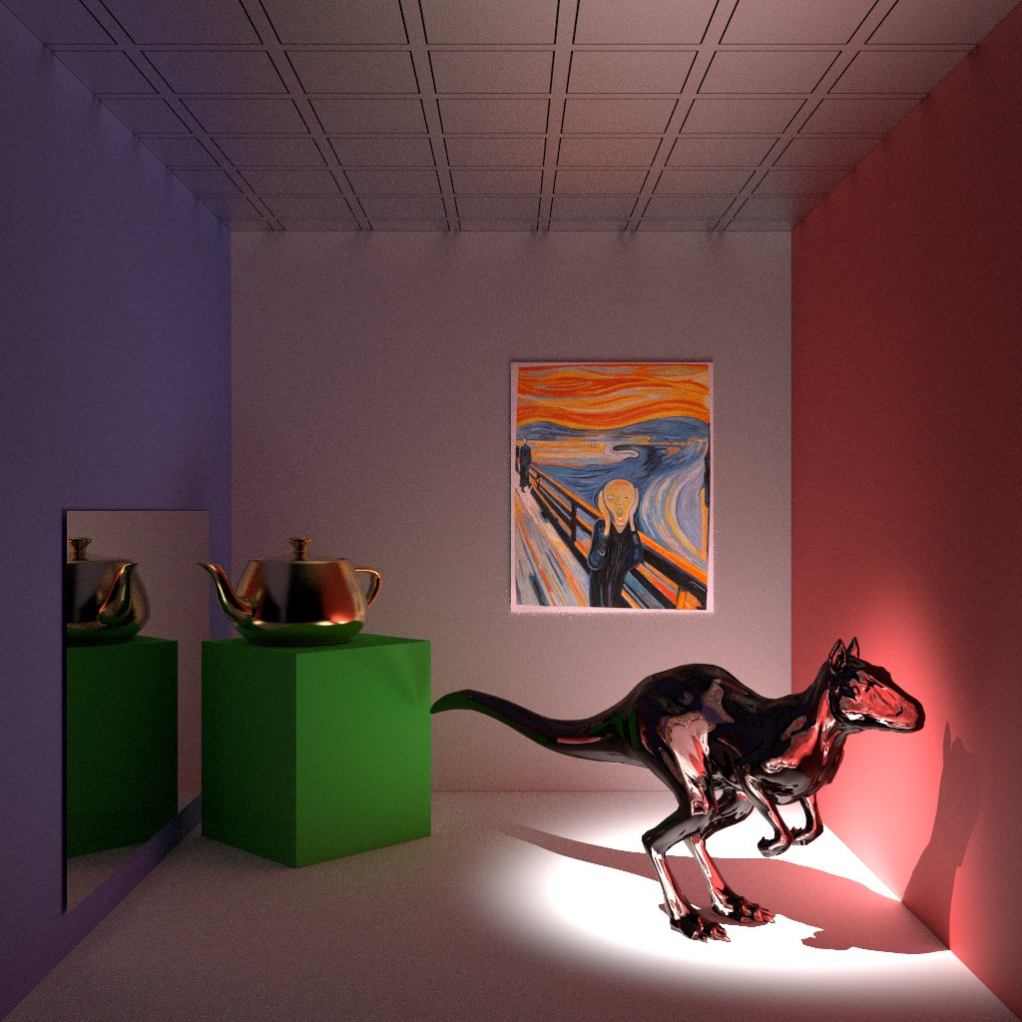

Figure . Default scene, rendered with path tracing.

# Experiments

In order to achieve the best result, and have a basis for comparison, some surface integrators and samplers to test were selected. Each surface integrator is tested with a different sampler. The planned elements are shown on Table 1.

Table 1. Planned experiments.

|  |  |
| --- | --- |
| Surface Integrators | Samplers |
| Path | Adaptive |
| Photon Map | Best Candidate |
|  | Halton |
|  | Low Discrepancy |
|  | Random |
|  | Stratified |

The result of each connection should generate an image and the time it took to render, for example, the path surface integrator with an unknown sampler generated Figure 1, which as given to the group to present the scene. The imagens to be rendered will have a width and a height of 800 pixels. The samplers’ “pixelsamples” argument will be 256, at the exception of the adaptive (“minsamples” set to 128 and “maxsamples” set to 256) and stratified samplers (“xsamples” and “ysamples” set to 16, with jitter). The Photon Map surface integrator receives the argument “causticphotons” as 10.000 and the “indirectphotons” as 20.000.

# Hypotheses

Caustics are the consequence of light rays being focused in specific regions as a result of refraction (light rays passing through the “killeroo” model on this case). In the current case study, it is believed that the photon map surface integrator will produce a better result than the rest. This is simply because the path tracing is unable to produce a caustic, due to its random nature, when a ray hits a point that should be a caustic, a random ray is generated, and the probability of this ray being on the right direction (the “killeroo” model) is very low (shown in Figure 2 as red rays). And so the caustic would be no more than a normal shadow using path tracing. The photon map, on the other hand, is the ideal algorithm for this scene, and can generate very realistic caustics.

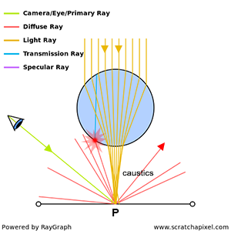

Figure . How a caustic shadow is formed.

# Results

On this section will be displayed all the images obtained, such as their rendering time. On Graph 1 is shown a global comparison between surface integrators and samplers.

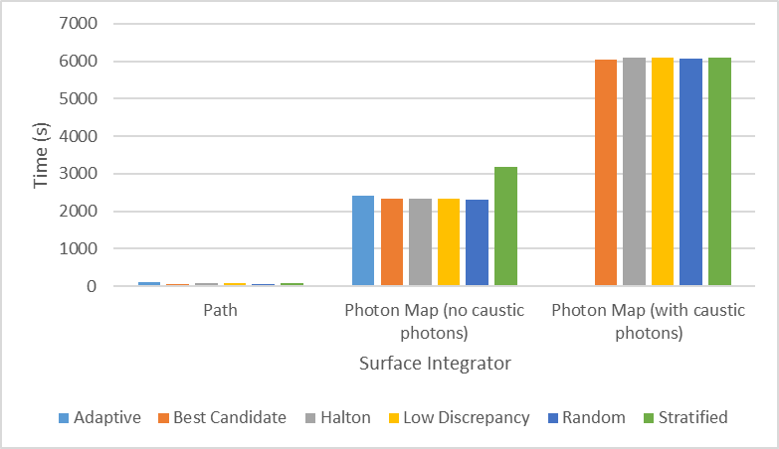

Graph . Global comparison between the studied algorithms.

## Path Tracing

This subsection is dedicated to the experiments with path tracing. On Graph 2 is displayed the rendering time of the images produced. It can be verified that the elapsed time was similar with a peak on the adaptive sampler.

As we are going to see in the next subsections, due to the nature of this exact surface integrator, the resultant images have a lot of noise, mainly on non-direct lighted surfaces as well as on shadows. As formulated on Hypotheses section, this surface integrator is not ideal for the simulation of caustic shadows. The path tracing is limited by two main factors: the number of rays shot and the randomness of the direction of news rays. More rays mean more accuracy, precision and quality but it means a huge increment on the rendering time. On the other hand, caustics are a unique light effect and the randomness of rays’ direction can make things much harder.

Graph . Rendering time comparison between samplers using the path tracing surface integrator.

### Adaptive

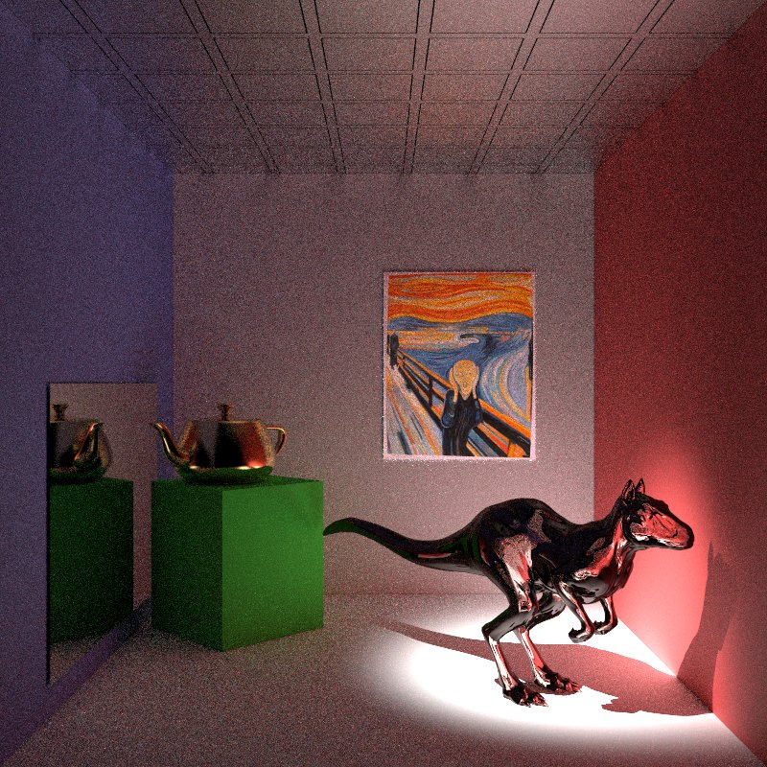

Figure . Scene rendered with path tracing and an adaptive sampler.

### Best Candidate

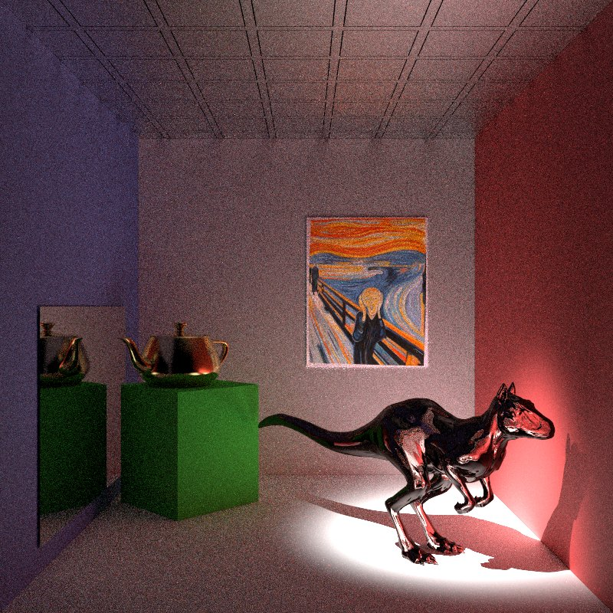

Figure . Scene rendered with path tracing and a best candidate sampler.

### Halton

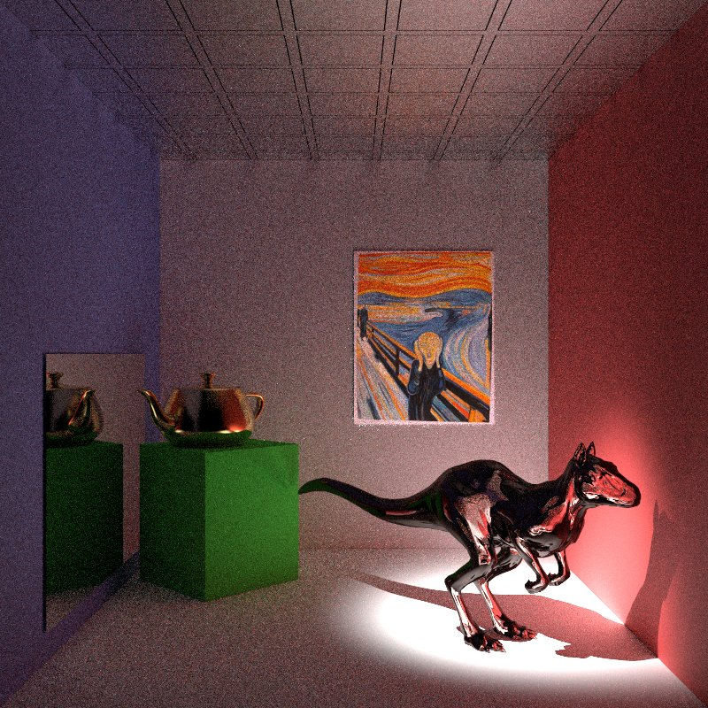

Figure . Scene rendered with path tracing and a halton sampler.

### Low Discrepancy

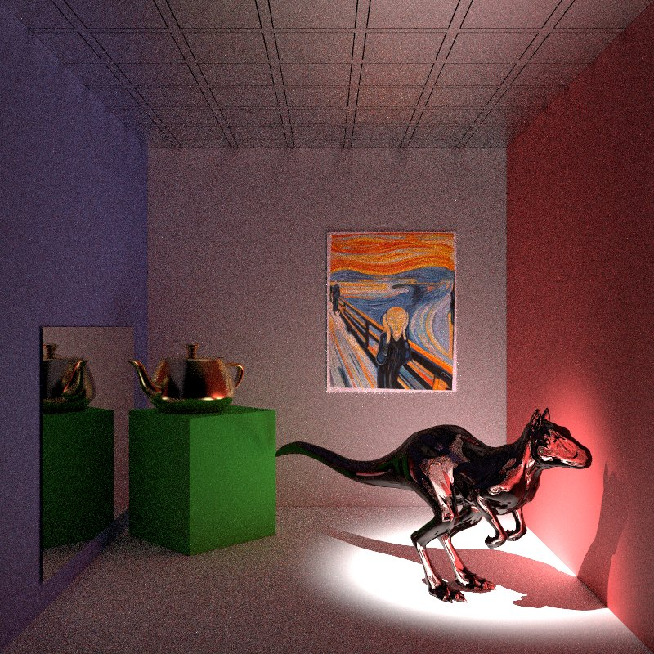

Figure . Scene rendered with path tracing and a low discrepancy sampler.

### Random

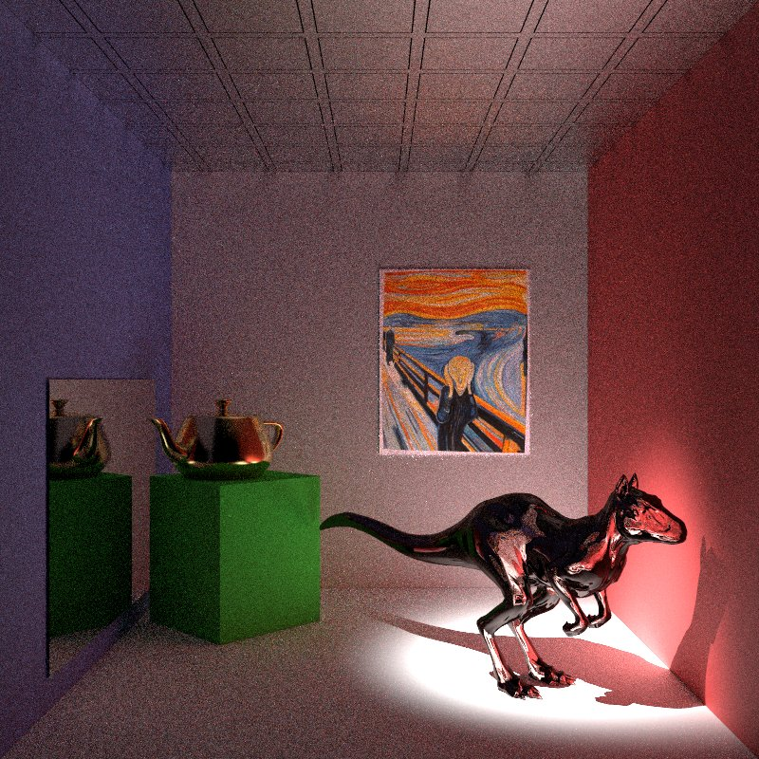

Figure . Scene rendered with path tracing and a random sampler.

### Stratified

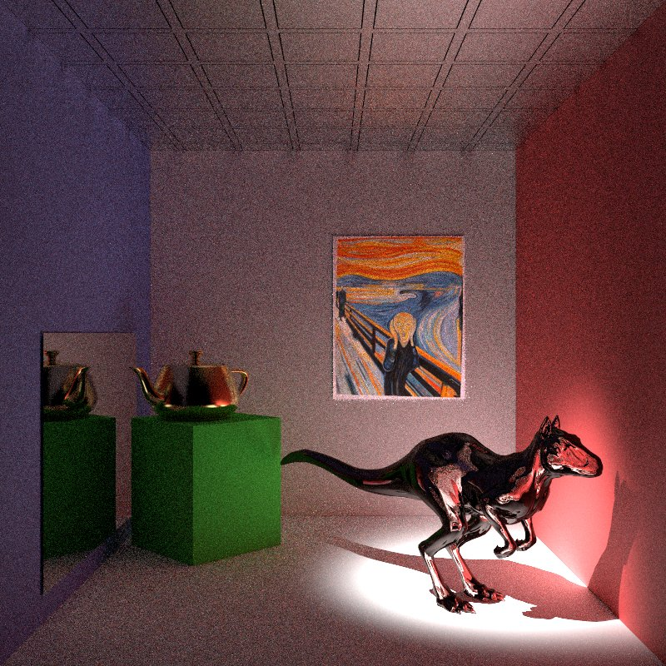

Figure . Scene rendered with path tracing and a stratified sampler.

## Photon Map With No Caustic Photons

From Graph 3 we also see that, in general, rendering times are very similar for all samplers. In this particular case, the outlier is the Stratified sampler. Comparing the elapsed times got from path tracing, a significant increase is easily detected. Photon Map (without Caustic Photons) rendering time is, in most cases, about 35 times greater. The reason behind this phenomenon is the number of photons chosen, which is significantly superior than the default path tracing settings. Consequently, the images’ quality is clearly better, however as there are no caustic photons, the shadow continues unfitting.

The big part of problems related with the non-direct lighted surfaces are now solved. The noise is incredibly smaller, almost undetectable. There are still some places where we can see some undesired side effects: around the lines that result from the intersection between the roof (top plane) with the walls (right, front and left planes) are some reflected colors which don’t make sense. We presume these artifacts appeared due to the fact the roof is a glossy surface, so it reflects like a blurred mirror. Similar things are visible among the floor (bottom plane) and the wall in front.

Graph . Rendering time comparison between samplers using the photon map tracing surface integrator with 0 caustic photons.

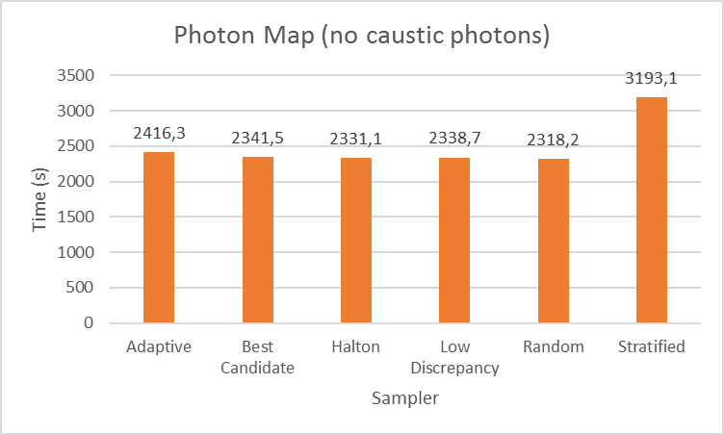

### Adaptive

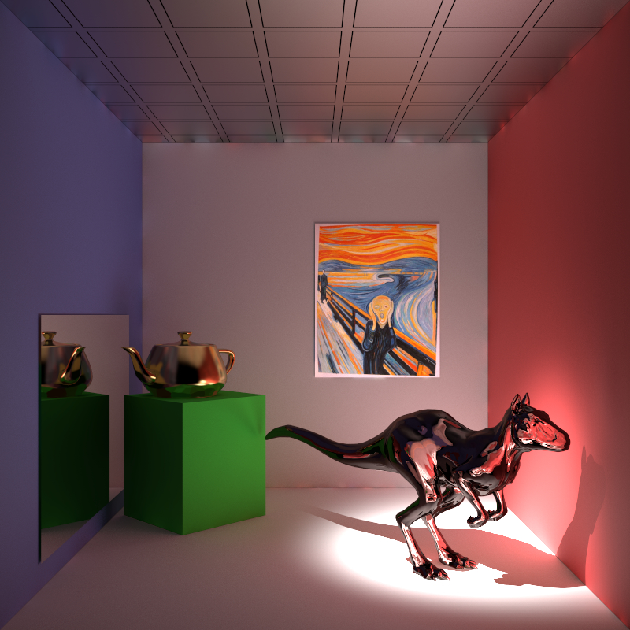

Figure 9. Scene rendered with photon mapping and an adaptive sampler.

### Best Candidate

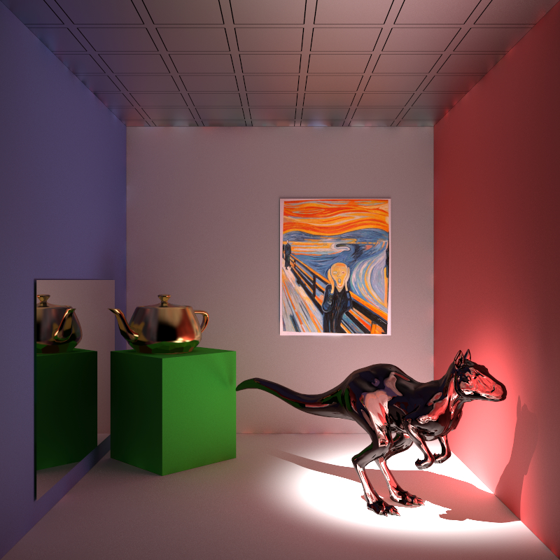

Figure 10. Scene rendered with photon mapping and a best candidate sampler.

### Halton

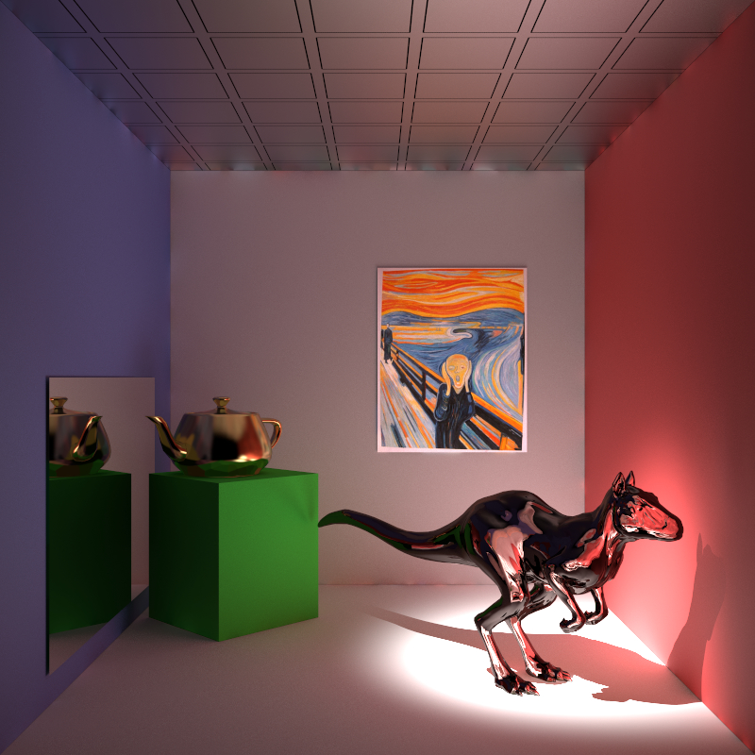

Figure 11. Scene rendered with photon mapping and a halton sampler.

### Low Discrepancy

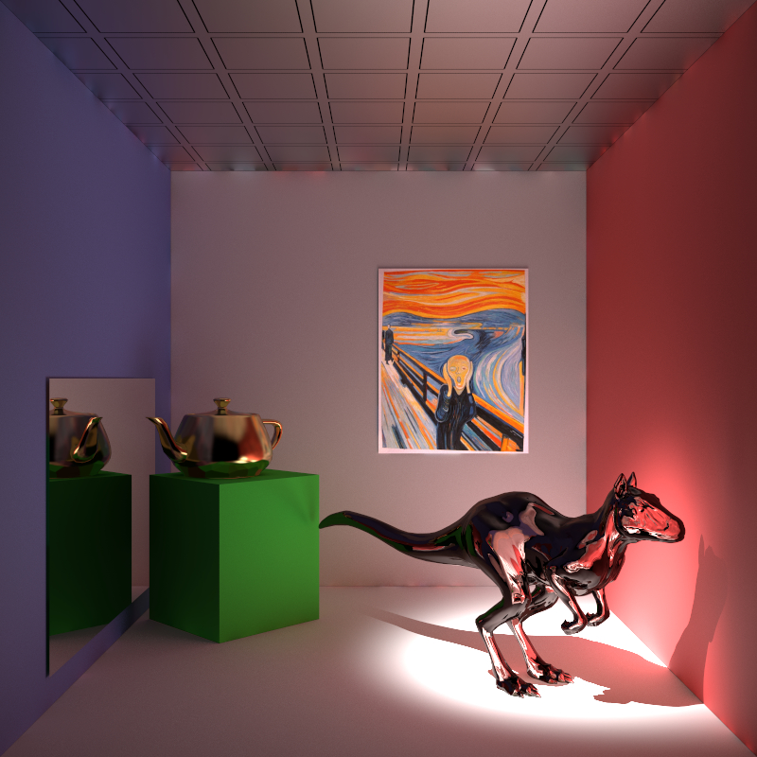

Figure 12. Scene rendered with photon mapping and a low discrepancy sampler.

### Random

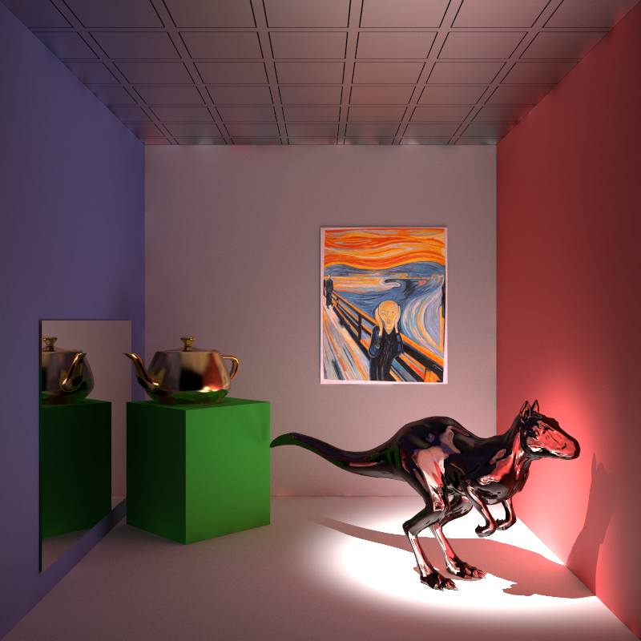

Figure 13. Scene rendered with photon mapping and a random sampler.

### Stratified

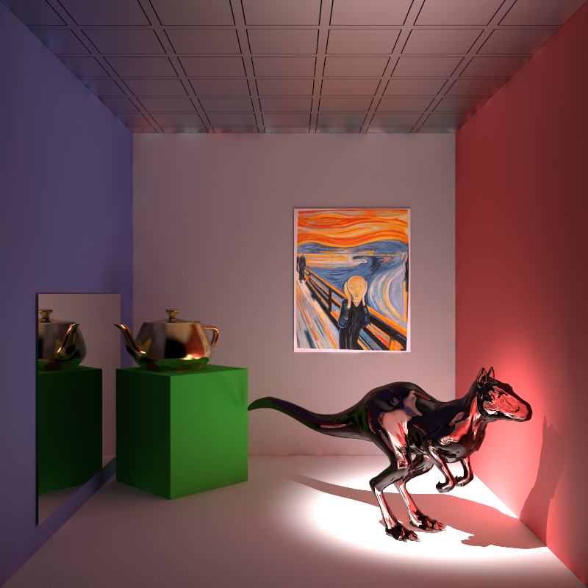

Figure 14. Scene rendered with photon mapping and a stratified sampler.

## Photon Map With Caustic Photons

With the insertion of the Caustic Photons the final images get even better look, nearly what we pretend from it. Yet, like it was expected, we there was another increase on the rendering time, which was approximately three times bigger comparing with the last implementation (Photo Map Without Caustic Photons) and almost 100 times bigger associating with Path Tracing.

Finally, the rendered image has caustics shadows, although they are not as we were guessing. According with the reference image, the caustic shadows must be much more well-defined, and not so glossy. Maybe this problem can be solved by changing the values of the variables that we considered as static. The previous problems related with the intersection of the planes, still persist, even on the reference image.

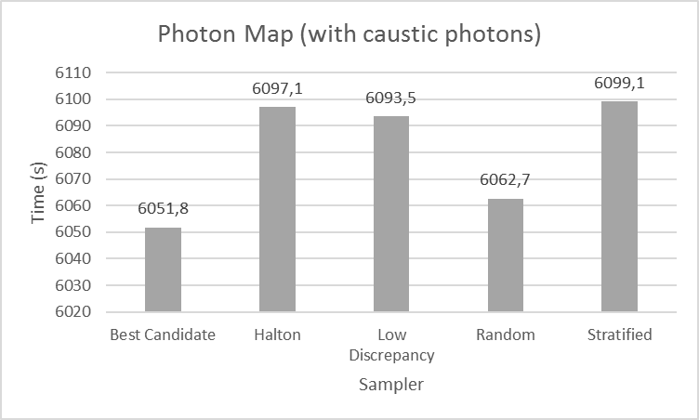

Graph 4. Rendering time comparison between samplers using the photon map tracing surface integrator with 10.000 caustic photons.

### Best Candidate

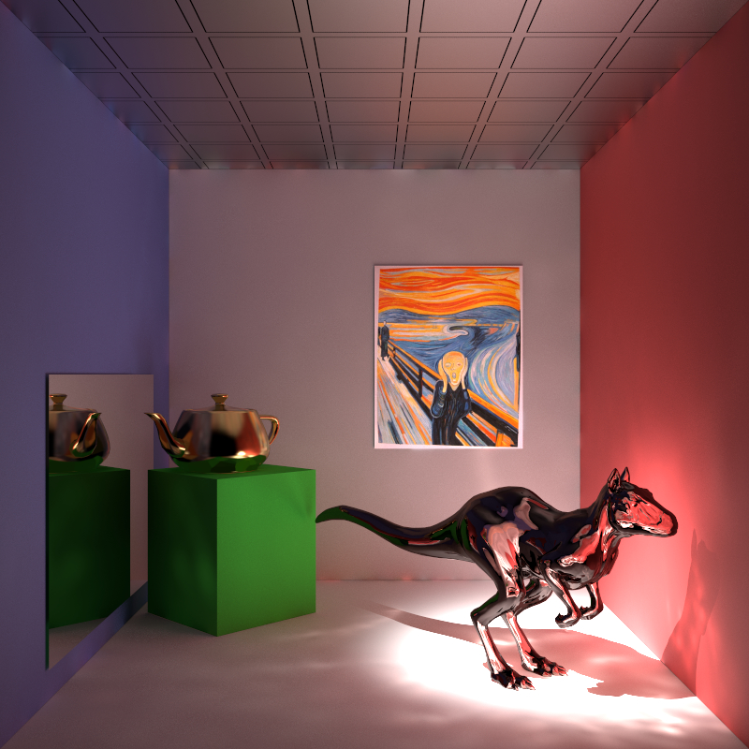

Figure 15. Scene rendered with photon mapping (with caustic photons) and a best candidate sampler.

### Halton

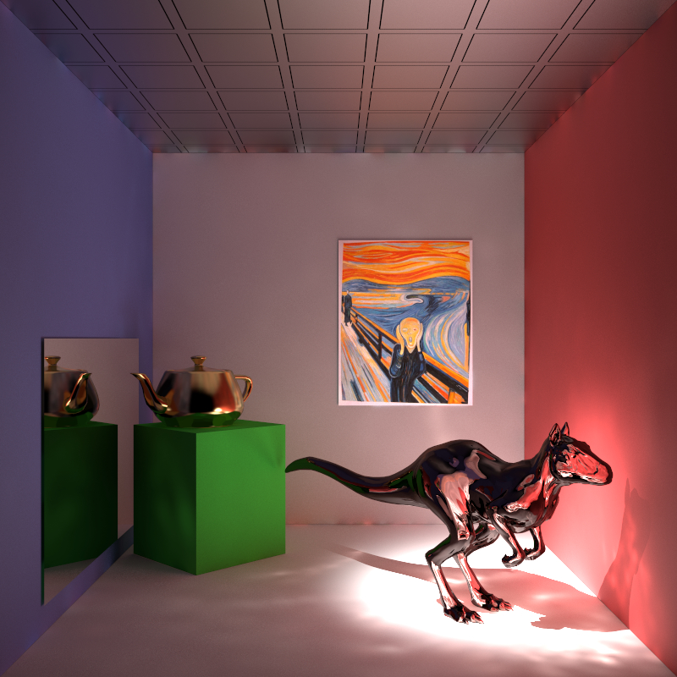

Figure 16. Scene rendered with photon mapping (with caustic photons) and a halton sampler.

### Low Discrepancy

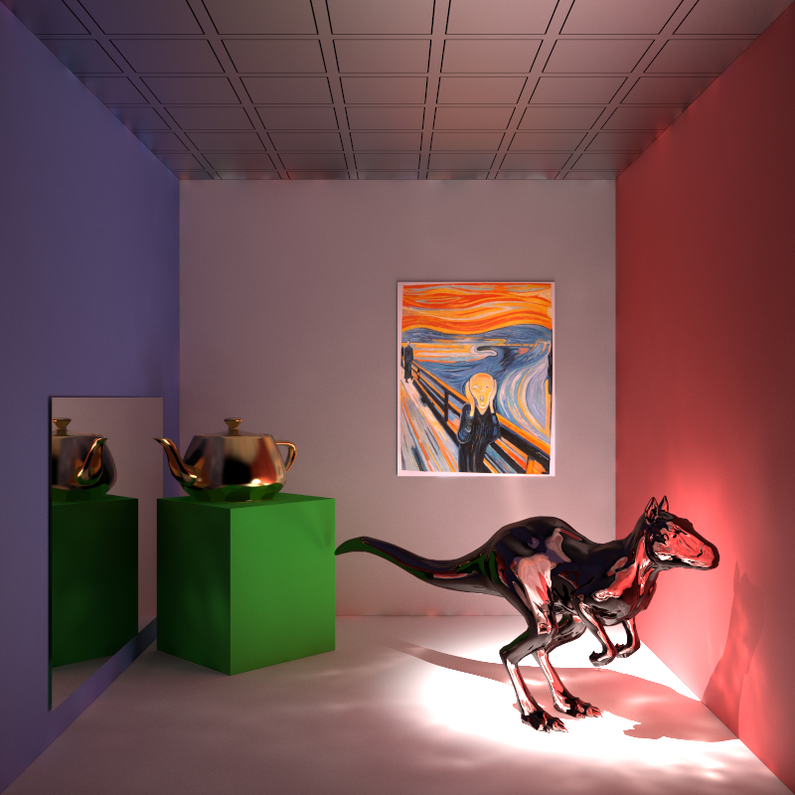

Figure 17. Scene rendered with photon mapping (with caustic photons) and a low discrepancy sampler.

### Random

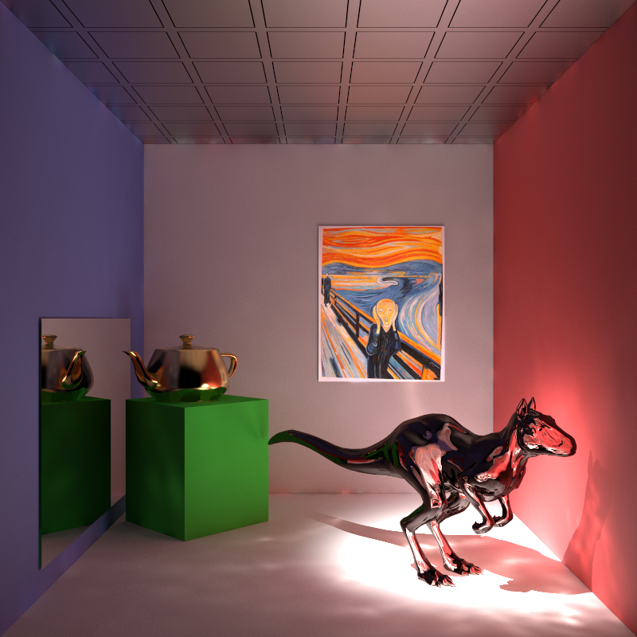

Figure 18. Scene rendered with photon mapping (with caustic photons) and a random sampler.

### Stratified

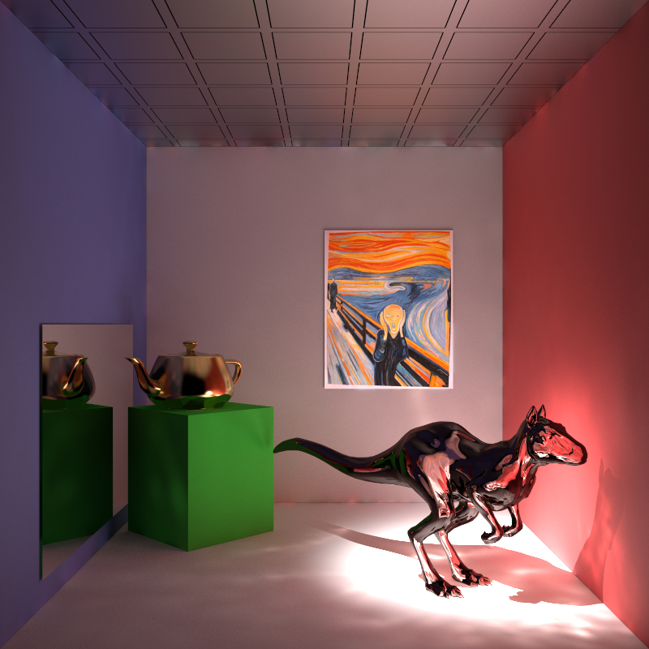

Figure 19. Scene rendered with photon mapping (with caustic photons) and a stratified sampler.

## Reference Image

To generate the reference image we used the photon map surface integrator with 1.000.000 caustic photons and 20.000 indirect photons, and the random sampler with 256 pixel samples; both the surface integrator and the sampler were chosen based on the best results we had achieved by the time. With the values used we can have a clear image and are able to see high quality caustics for comparison with the rest of the scenes rendered.

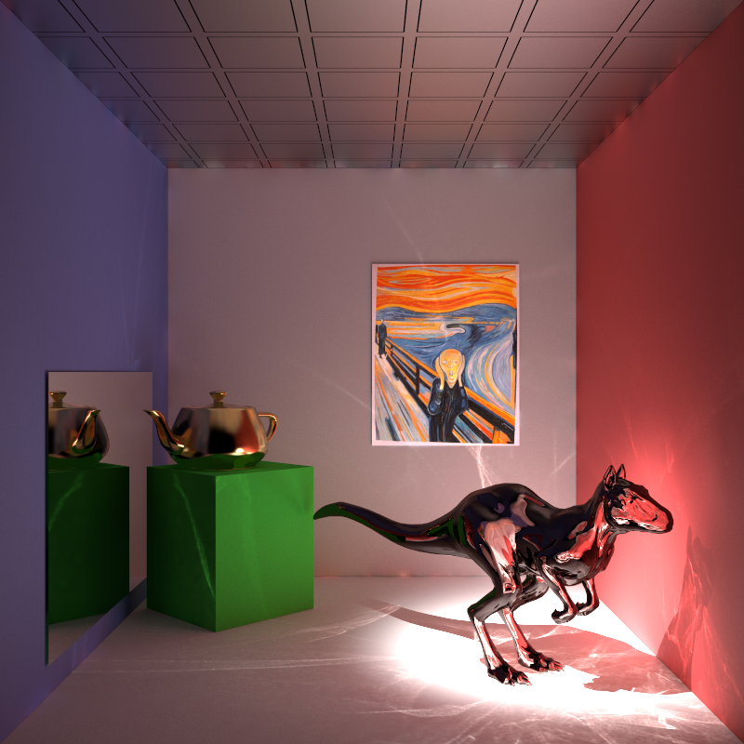

Figure 20. Reference scene.

# Conclusion

After observing and comparing all the resultant images from the various studied algorithms, the most immediate conclusion is that there is little difference between the considered samplers, but there is a noticeable variance between the surface integrators. Graph 5 presents the results obtained when the numerous final imagens were compared with the reference image through the “rmse.exe” program from PBRT project. This graph proves just this point, were between samplers the RMSE variance is insignificant, but between surface integrators it is not.

_____----- falta falar dos seguintes pontos:

* espirito critico!
* trade of entre X e Y
* refletir sobre os resultados obtidos e porque
* falar sobre a adaptive do photon map com photoes cáusticos (não fizemos)
* problemas que tivemos (falar do metropolis)
* trabalho futuro

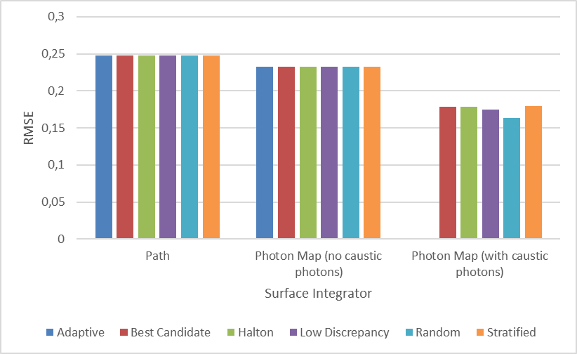

Graph . RMSE comparison between surface integrators and samplers.